Streamlining IT Procurement:
Automating Standard Laptop Orders with Flow Designer

TASK INITIATION
Milestone 1:
Flow Activity 1: Create a Flow to Create Catalog task to update the short description after Approval the service Request and it will be Assignment group to Hardware.
INSTRUCTIONS:
1. Open service now.
2. Click on All >> search for Flow Designer
3. Click on Flow Designer under Process Automation.
4. After opening Flow Designer Click on new and select Flow.
5. Under Flow properties Give Flow Name as “ Standard laptop task”.
6. Application should be Global.
7. Select Run user as “ System user ” from that choice.
8. Click on Submit.
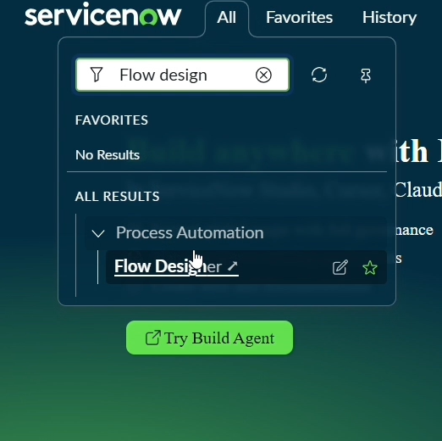

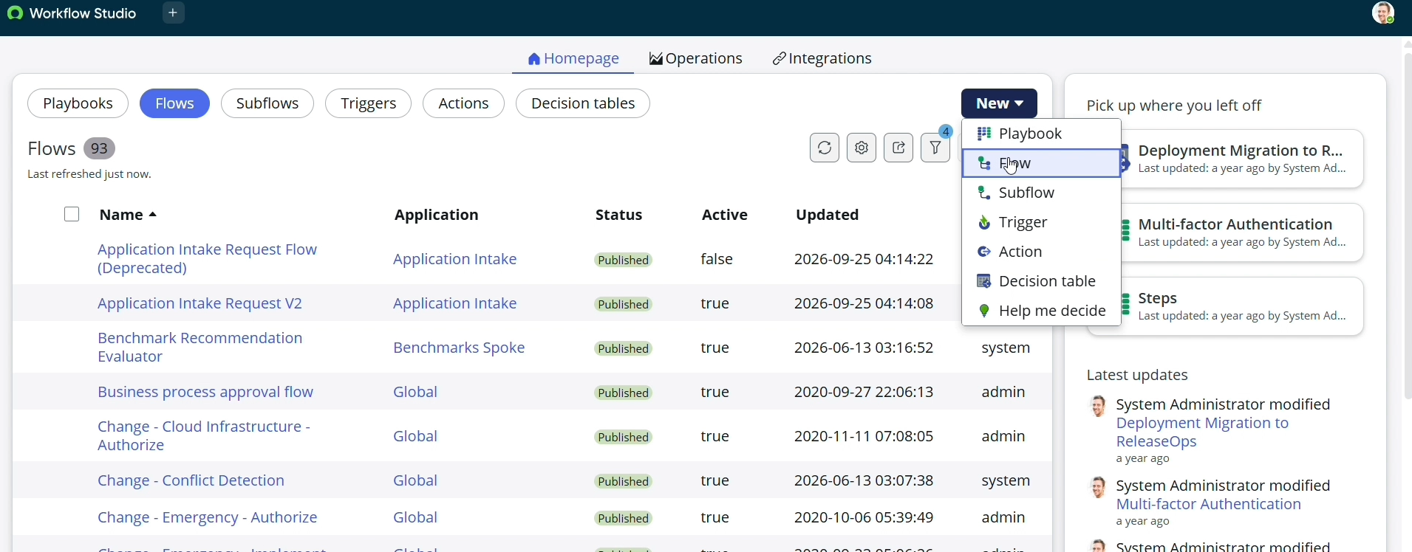

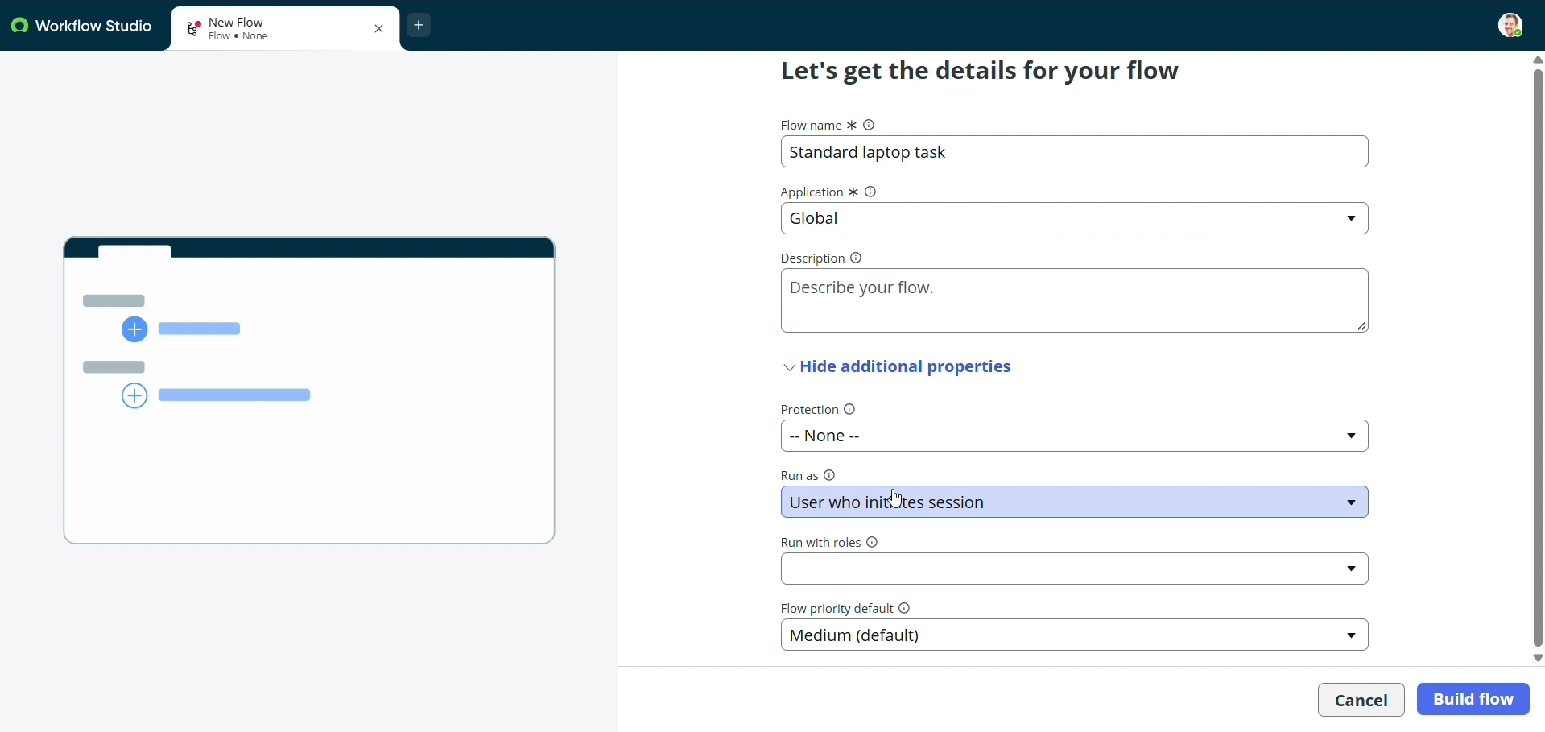

9. Click on Add a trigger
10. Select the trigger in that Search for “ Service Catalog ” and select that.
11. After that click on Done.

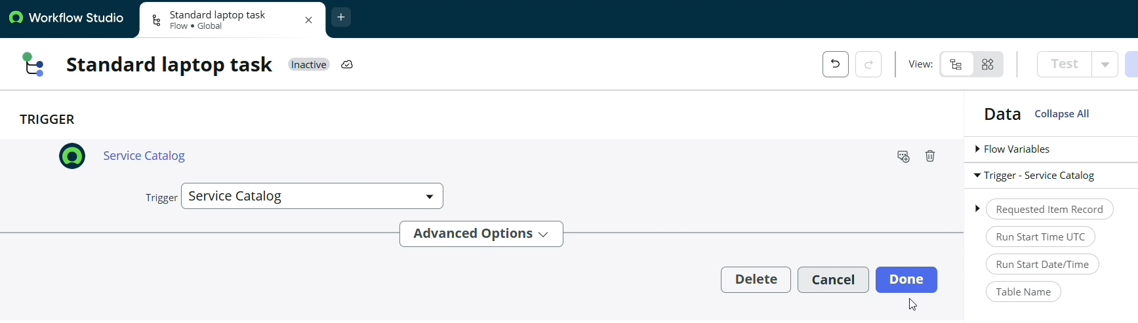

12. Now under Actions.
13. Click on Add an action.
14. Select action in that search for “ Create Catalog Task ” and select that.
15. Mention these in that action
16. Action as Create Catalog Task
17. Drag and drop the Requested Item Record in the Request item.
18. Table will be auto populated as a Catalog Task.
19. Mention the short description as “ Laptop need to Configured ”.
20. Click on add field value
21. Select description field and value as “ Laptop need to Configured ”.
22. Select Assignment group field and value as “ Hardware ”.
23. Select Approval field and value as “ Approved ”.
24. Leave the remaining as default and click on Done.
25. Click on save the Flow.
26. And Click on Activate again click on Activate.

